OLIVER Circulation Procedures

Turn the computer on
- Press CTL ALT Delete as usual. Enter your user name and password.
Use this URL (add your school Oliver URL)
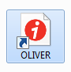
OR
- In shortcuts open OLIVER
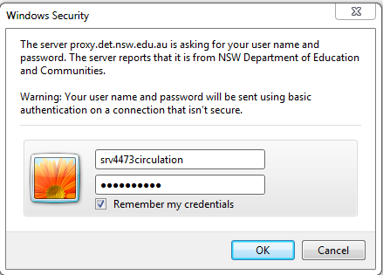
- Enter the log on details
User name: (add your school details)
Password: (add your school details)
- You are now in OLIVER library.
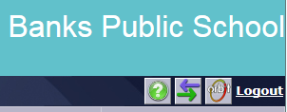
- Press the button at top right with a purple arrow and a green arrow.

- You are now at OLIVER circulation desk.
Warning notice of issue with resource or loan. This needs to be answered to continue. (Use Mouse) Answer as you see appropriate, it might let you know a book is overdue, has been marked missing, on loan to another child etc.
Click in this window to scan student barcode/books. You can type in students first or last name

Student details

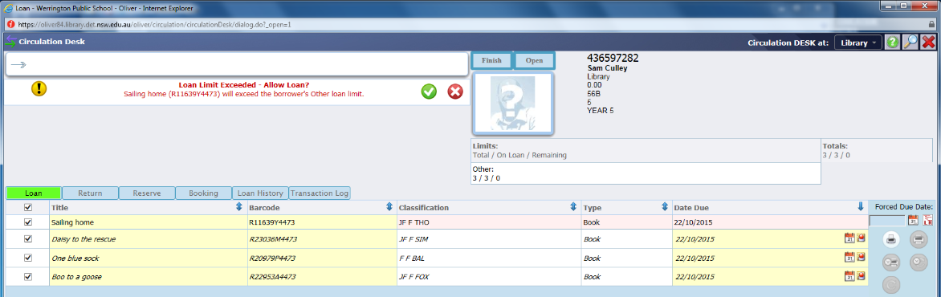
Loan/Return tabs. Switch between these buttons depending what you would like to do. Type either their first or second name to begin borrowing for a student.
Scan barcode of book to return items.
Student’s current loans. Note overdue books will be in red.
Loan/Return tabs. Switch between these buttons depending what you would like to do.
Student’s current loans. Note overdue books will be in red.

