School Libraries System Upgrade: from OASIS to OLIVER
Oliver replaces My Library. There are two interfaces for schools, the Oliver interface for staff and Orbit for students
Staff and Students
What advantages does Oliver offer?
- Interactive
- Link with e-books and digital learning objects
- check loans, make reservations, request new resources, and pursue interests to get alerts of latest resources available
- publish reviews to share with other users
- check PRC titles available
- create and check resource lists
- save searches
- update borrower details including loans, returns and overdues automatically.
- Communicate with users via email to notify of loans, reserves and overdues.
- Real time updates for loans, newly resources displaying and reading lists
Accessing Oliver
- Log onto the DEC portal
- Add the Oliver link to your Home page
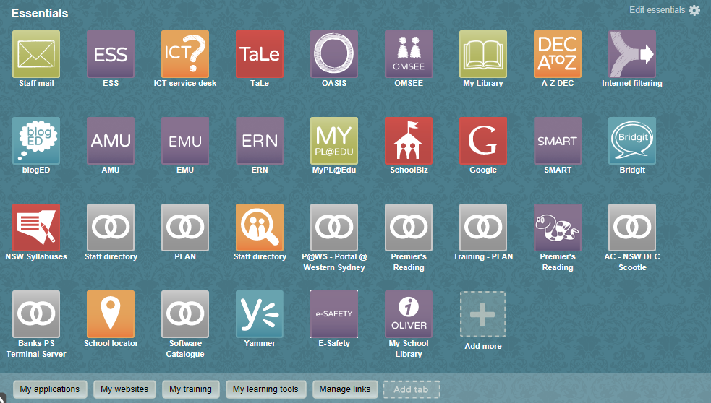
Go to My applications
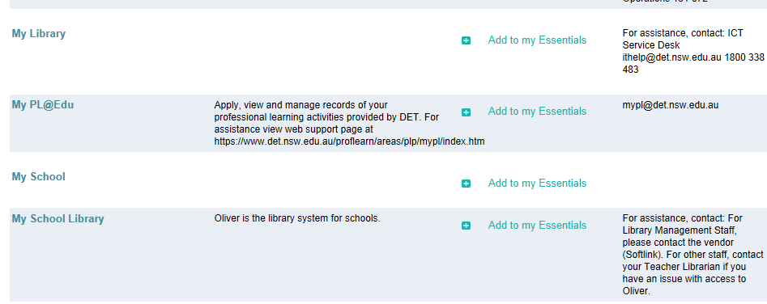
Add My School Library to my Essentials

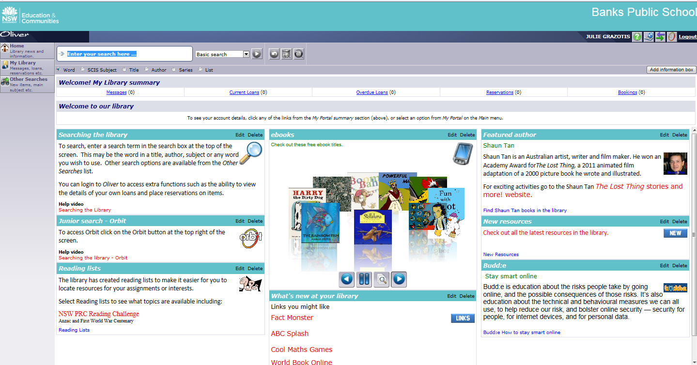
Oliver features

- Search
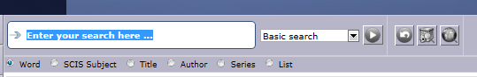

- Reading Lists- Premier’s Reading Lists
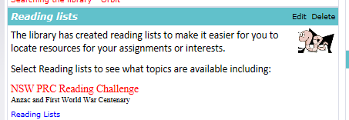
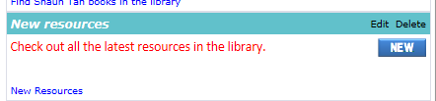

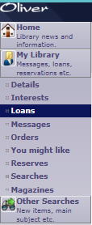
- New Books
- My Library
- Check your current and overdue loans
- Check saved searches
- Check message such as overdue notices or reservations
- Make reservations
- Browse through suggested resources based on previous searches and borrowing history

